21-08-2026:
Cloud Computing:
Cloud Computing means using IT resources such as servers, storage,
database, networking and applications through the internet instead of owning and maintaining physical hardware.

Why cloud computing?
- Cost saving—no need to buy large amounts of hardware
- Access anywhere –user resources through the internet
- Scalability –increase or decreases resource when required
- Fast deployment – create server and services quickly
- Security –cloud providers provide security feature
- Pay as you use – pay based on resource usages

Major cloud Providers:
- Azure
- AWS
- Google cloud (GCP)

Three Cloud model Services:
LaaS -- Infrastructure as a service
PaaS -- platform as a service
SaaS – software as a service

LaaS -- Infrastructure as a service
Laas provider virtualized IT infrastructure such as Servers, storage and networking through the cloud
PaaS: platform as a service
PaaS provides a ready-to-use platform for developing deploying and running application
Without managing the underlying servers and operating systems
Example: Azure app service
Google app service
You Mainly manages:
Application
Code
Data
Cloud provider manages:
Serves
Storage
Networking
Operating system
Runtime
Planform
SaaS: Software as a service
Saas provides complete software application over the internet ready for users to access and use.
Example:
Gmail
Microsoft 365
Teams

You Main manage:
Your data
Application setting/user

Cloud provider manages:
Application
Runtime
Operating system
Servers
Storage
Networking

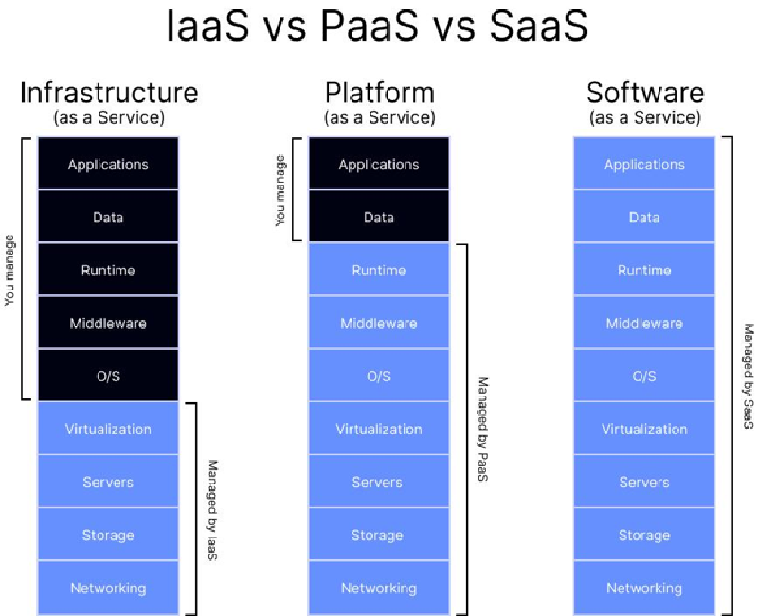

24-08-2026:

1.3 Azure Global infra

What is azure portal?

The azure portal is a web based interface user to create , manage, monitor and delete azure resource.

https://portal.azure.com

What is Azure Subscription?
A subscription is an azure account that allows you to create and manage resources.
Without a subscription you can not create any azure resources.
Type of subscription
Free trail
Pay-as-you-go
Enterprise agreement (EA)

Subscription respobilities
- Billing
- Cost management
- Resource limits(Quotas)
- Access control

Xyz – Abcd
A company has separate subscription for
- Development Subscription
- QA subscription
- Prod Subscription
This separation helps isolate costs, permission and environments

Resource Group:

What is A resource Group?
A resource Group is logical container that groups related azure resources, it helps organize and manage resource together

Example:
- VM
- Storages
- Virtual network
- Public Ip Network Interface
All of these can place in one resource Group

Dev RG
QA RG
Prod RG

Why use Resource Group?

